Current Operable Unit 3 Remedial Progress for Week Ending 1/15/10
Creamer Environmental Inc., National Grid’s Remediation Contractor, has restarted the excavation and backfill tasks where the LIRR tracks were relocated. To date 122 trucks have transported approximately 3107.25 tons (2071.5 cubic yards) of soil to Bay Shore Soil Management (formerly ESMI of NJ) for thermal desorption. Additionally 33,789 gallons of impacted excavation water has been disposed of at Clean Waters of Staten Island and Bridgeport United Recycling in Connecticut. Phase 1 sheet pile installation and construction was completed on January 11th. Full scale excavation and load out of impacted soil has restarted on January 12th.
GEI, National Grid’s Remediation Oversight Consultant, continues to perform CAMP (Community Air Monitoring Program), Noise and Vibration monitoring. CAMP, Noise and Vibration monitoring will continue throughout the project.

Two-Week Outlook
Excavation and load out of Cells 4 and 5 are slated to start week beginning January 18th .It’s also anticipated the remaining cells 6 and 7 will be excavated in the following week. The back filling and restoration phases of the project will commence immediately after each individual cell is excavated to design depth. Phase 1 is anticipated to continue until late January or mid February.
General hours of operation will continue to be Monday through Friday, 7:00 AM to 3:30 PM. However, work hours will be extended when necessary to maintain schedule or to complete critical tasks. A typical operations shift is anticipated on January 18th (Martin Luther King Jr’s. birthday).

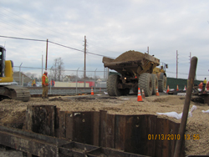
Starting backfilling operations of Cell #3
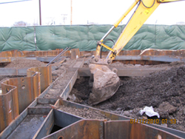
Starting excavation of cell #3

